

UNIVERSITY OF SAN CARLOS

School of Engineering

Department of Computer Engineering

**FOODA**

Submitted to the Faculty Member of the

Department of Computer Engineering

Engr. Arnold Roso

Submitted by:

Kristian Daniel Alunan

Joshua Villahermosa

Date of Submission

**Project Details and Features**

The FOODA app is a web-based application to let restaurants have an avenue to be able advertise their promo’s to people easily. The users can also benefit from this system to be also be able to gain fast information on their favorite restaurant’s new promos without having to be on site when it happens, saving them their costs of time and transportation.

**Main Features**

1. Users

- Promo Seeking, as they would be able to browse through different restaurants and their offers

- Fast Notification, by having an app that tells them that one of their favorite restaurants has a new promo, saving them the time of trying to know there is

2. Restaurants

- Save man power, as they would be able to assign people who were supposedly giving out flyers unto other types of jobs

- Have a better scope of advertisement, since they would be able to reach people who are not anywhere near their establishment

**Operating Features List**

- User Restaurant Search Menu

- User Favorites List

- Restaurant Post Creation

- Restaurant Post Publishing / Information Dissemination

- Admin Restaurant Account Creation

**Database Design**

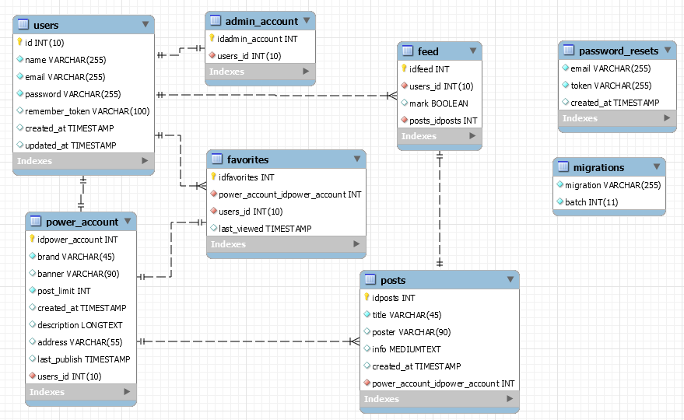

**Business Model Canvas**

